**GUJARAT TECHNOLOGICAL UNIVERSITY**

Chandkheda, Ahmedabad

Affiliated

Vishwakarma Government Engineering College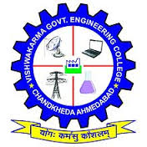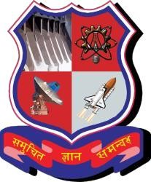

Chandkheda, Ahmedabad

A Report On-

# Online Education System

Under subject of

## DESIGN ENGINEERING – 2A

B. E. III, Semester – V

### Computer Engineering

Submitted by:

Group: 248769

Sr. Name of student Enrolment No.

1. Joshi Prashant 180170107043

2. Jodhani Mayur 180170107042

3. Lad Deep 180170107050

4. Bhatiya Riya 180170107005

Prof. Kaushik K Rana

(Faculty Guide)

Prof. Mansukh T Savaliya

### Head of the Department

Academic year (2019-2020)

**Certificate**

This is to certify that the project entitled “Online Education System” is submitted by

1. Joshi Prashant Shashikantbhhai

2. Jodhani Mayurkumar Kanubhai

3. Lad Deep Pravinbhai

4. Bhatiya Riya Ashish

In partial fulfilment of the course Design Engineering 2-A (3140005) for the year 2020 to department of Computer Engineering, Vishwakarma Government Engineering College, affiliated to Gujarat Technological University, is a record of bonafied work carried out under guidance and supervision. The results embodied in this project report have not been submitted to any other Institute for the award of any Degree or Diploma.

Guided by:

Prof. Kaushik K Rana, Assistant Professor

Department of Computer Engineering,

Vishwakarma Government Engineering College,

Chandkheda-382424

**Index**

1. Project Abstract
2. Understanding the problem
3. Design calculations
4. Canvas:

* AEIOU
* Mind Map
* Empathy
* Ideation
* Product development

1. Prototype
2. Conclusion



**Project Abstract**

The future of education will be educational technology. As per current scenario of Covid-19, world is facing a great loss. But advancement in technology provided the solution to many problems preventing human physical contacts. Thus online education system helps to provide remote learning with flexibility in time and resources making it more effective. Thus educational technology can help learners to learn and practice effectively. Advancement in AI, brings new ideas. The project’s main feature is to provide effective learning experience to the user. In order to have it, the system would track the learner’s pace, ability to grasp concepts, overall learning phase and much more. On further analyzing, the system will provide better learning experience to the user as per his/her adaptability. This will allow the user to be addictive to learning new things and developing new skills. Learner can further practise the concepts to the real world applications providing AI driven implementation based learning. We have introduced game based learning approach which deals with developing new own strategies and applying it in different ways, increasing learners interest.

Thus project aims to develop an online education system providing better and effective learning experience.



**Understanding the Problem**

As, we know we all are suffering from the big pandemic situation; covid-19. It is the deadliest virus, which is spread in the entire world across the globe. People are dying and people are not only in problem biologically but also employment, economic, starvation and many more. The main problem which our team encounter is education. so, to overcome this problem we want to make online education system in which students, teachers and those who want to learn and teach can interact. This will work well for student because students don’t have to attend physical lecture they can learn virtually and can get to know to learn other courses according to their performance and liking in the previous course.

We have observed that people want to do things and learn things which they like and in which they are expert and try to learn new in that domain. People at small age also want to teach people if they know something at the same time they are student also, but they are not getting proper platform. They need practice of certain things after completing particular part so they can practice and master in that thing.

And people are also happy that they don’t have to drive themselves to college or school and stuck in traffic rather than they can stay at home and work and utilize that time to do some productive work and can enhance their skills in any domain they can like. They started going online and learned things.

Following were the problems faced majorly.

1. Lack of social learning.

2. Students were suffering loss in their studies.

3. Unable to have physical mode of education due to Covid19.

4. Inflexible learning schedule and unaffordable fees.

5. Learners were not able to have a platform where they can have hands on practice.

**Design calculations**

**Use Case Diagram:**

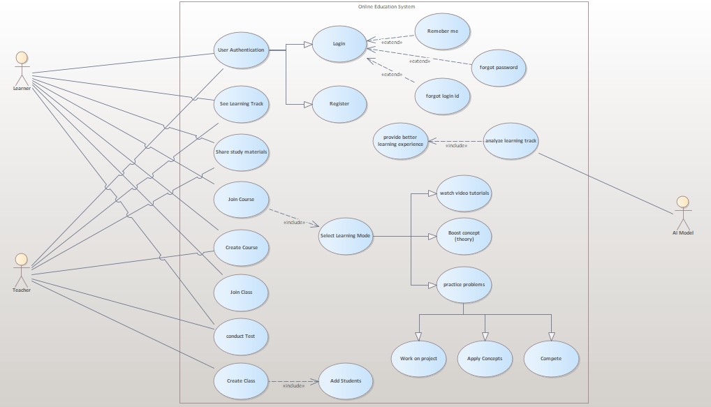

**Canvas**

**AEIOU: 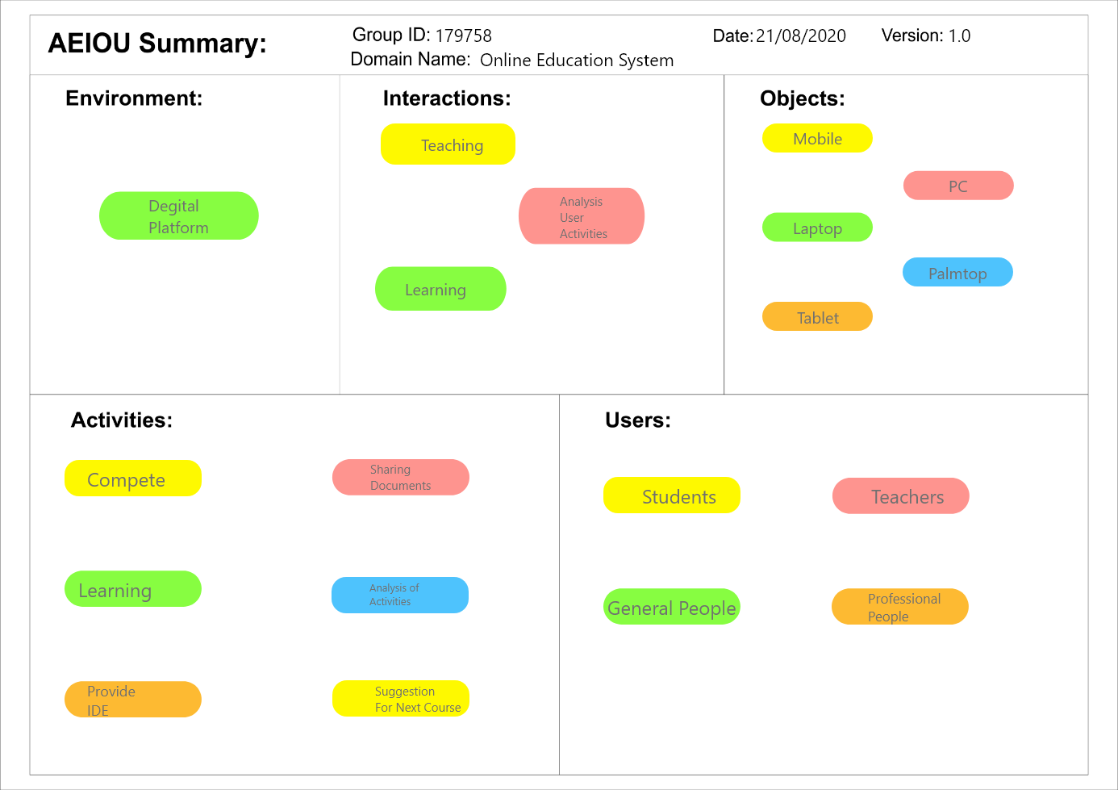**

AEIOU stands for 5 elements to be coded: Activity, Environment, Interaction, Object, and User. Activities are goal-directed sets of actions—paths towards things people want to accomplish. Like In this, we want to provide a better online platform for learning new things. Interactions are between a person and someone or something else; they are the building blocks of activities. Online Education System will be used by the users like students, teachers, general people who are interested in learning new things, etc. Objects are building blocks of the environment, key elements sometimes put to complex or unintended uses. What are the objects and devices people have in their environments and how do they relate to this platform? In proposed system, object will be technical gadgets like laptops, tablets, mobile phones, etc.

**Empathy:**

**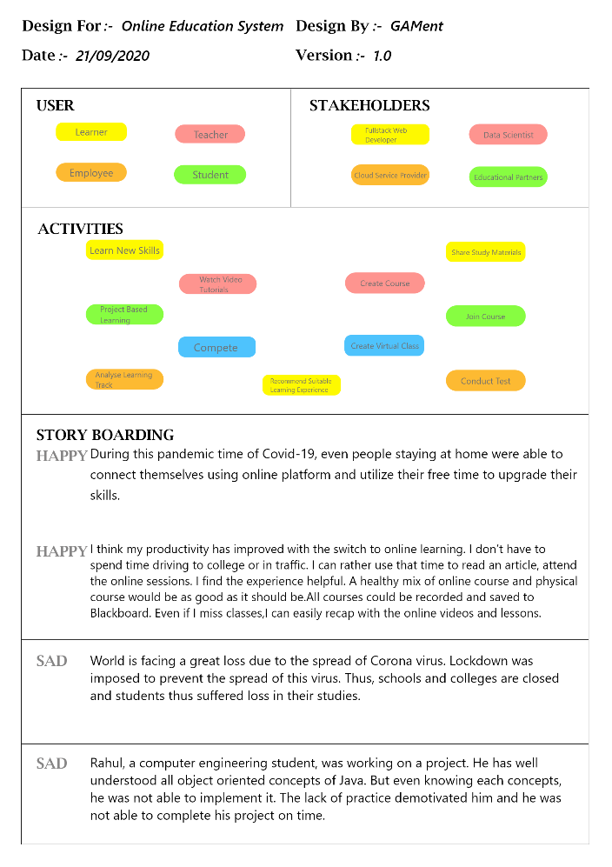**

Empty Canvas is used to develop a deep, shared understanding and **empathy** for other people, an **Empathy** Canvas is a tool that helps describe aspects of a user's experience, needs and pain points. This Canvas allows us to quickly understand our users' experience and mindset.so that we can upgrade our system in a better way. As we mentioned in AEIOU canvas, our user will students, teachers, general people who are interested in learning new things, etc. For the sake of development of application, main stack holders would be Educational partners, Fullstack Developer, Data Scientist, etc. For Education System the main activity would be learning new skills, watching video tutorials, project-based learning, competition with co-learners. The main activity which is differ from the existing system is we will be analyzing the learning record of the learners. And the basis of that we will suggest learners about what they should do next in order to enhance their skill in particular domain or field.

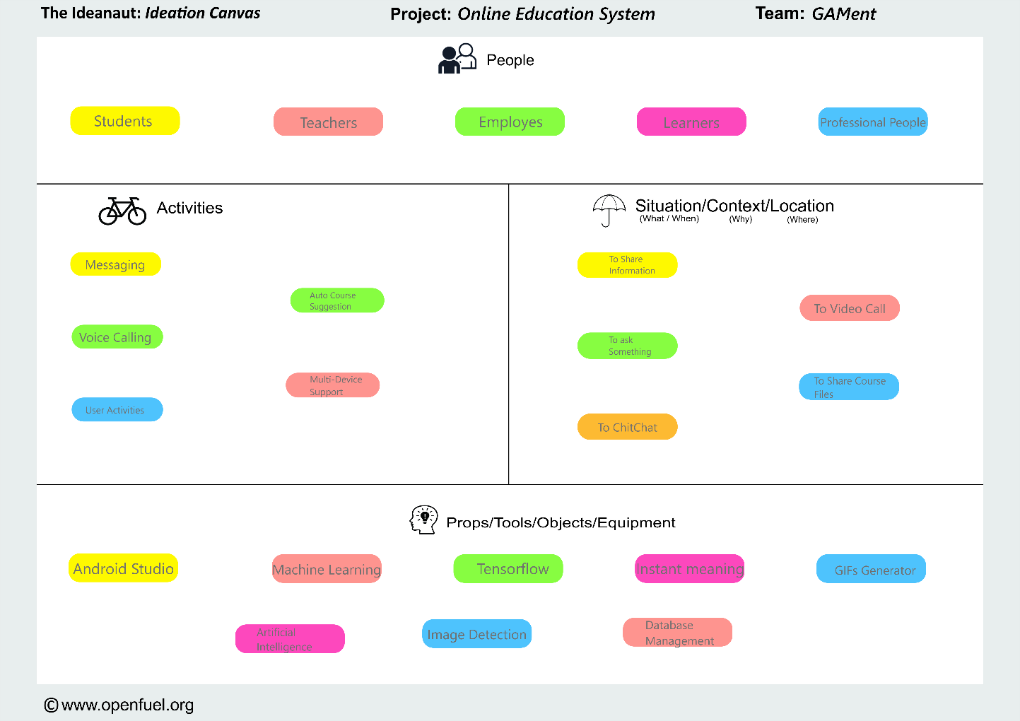Ideation:

As mentioned above, user of the system will be students, teacher, employees, learners, professional people, etc. The user/learner can perform some activities like asking queries about their enrolled courses in the Discussion Forum, watching video lecturers through web application and more. While learning from the online resource, some students find it difficult to practice their skill in particular domain. In current scenario we should be able to practice our skill in real-life situation so that we can understand topic. Some learner also finds the difficulty in searching the right path to accomplish their goal. While our system will provide best way to accomplish the goal of use from the analyzing the way learning is going.

In order to develop this kind of system, we need some powerful tools that can manage the heavy load of this system like Android Studio to build App in Android platforms as well as we need to XCode to build applications for iPhone. For analyzing the track of learner, we are using machine learning algorithm to provide best efficiency in analysis.

Mind Map:

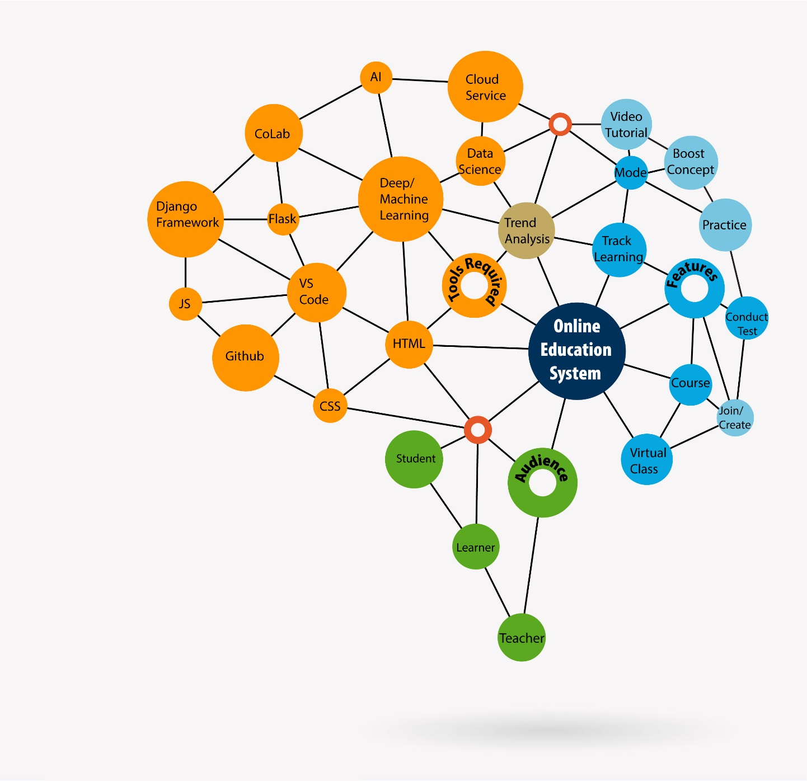With a central idea of **Online Education System**, we have drawn a mindmap which have three important aspects **Audience, Features and Tools required** shown in it. On top of that, we have chosen brain like structure which signifies a neural net which has large interdependency between each node in three aspects as mentioned above. As, we emerge out from the central idea, we discover nodes required in that aspect.

**Audience:** Targeted audience are students, teachers and all other enthusiats willing to learn and capable to teach, globally.

**Features:** Features as of now would be to provide courses in various modes like video tutorials and theoritical concept boost. Learner would be able to learn along with practice using hands on projects and various tests. Course would be equiped with virtual class creation. Student can track their learnings and will be getting suggestions about which course to do next on the basis of their trend analysis. These courses can be done as per students feasible schedule.

**Tools required:** We are planning to provide web application as of now. So, we would require HTML, CSS and related frameworks to implement it using python based APIs Flask and Django framework. As we are to provide better learning experience, we willl use machine learning and AI to analyze the trends. For database and other requirement, we would be using cloud services.

Product Development Canvas:

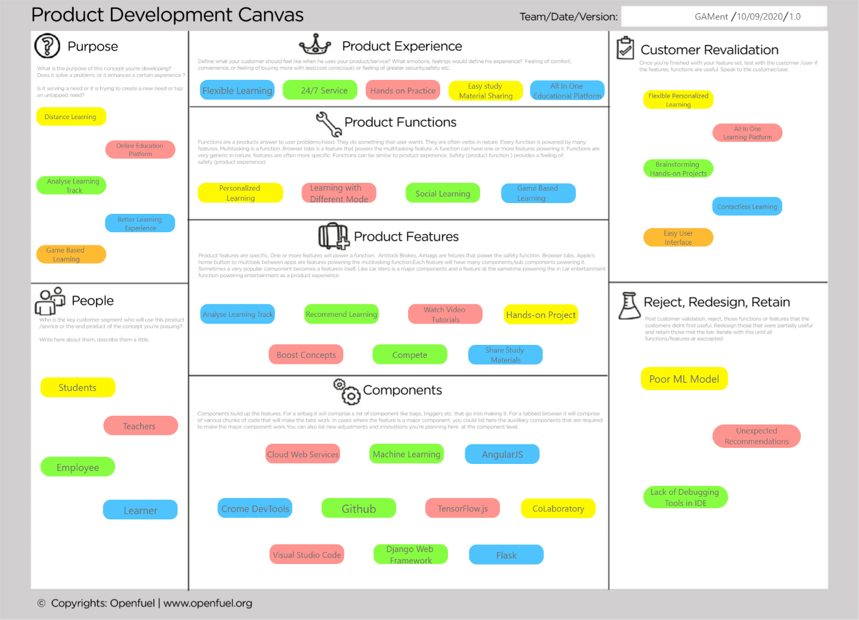

Prototype

AI driven learning using Web Application:

URL: <https://pj-25.github.io>

**PC view:**

|  |  |  |  |  |
| --- | --- | --- | --- | --- |
| E:\work files\DE + ssip\DE_Sem5\1603971800021.jpg | E:\work files\DE + ssip\DE_Sem5\1603971800016.jpg | E:\work files\DE + ssip\DE_Sem5\1603971800012.jpg | E:\work files\DE + ssip\DE_Sem5\1603971800008.jpg | E:\work files\DE + ssip\DE_Sem5\1603971799998.jpg |

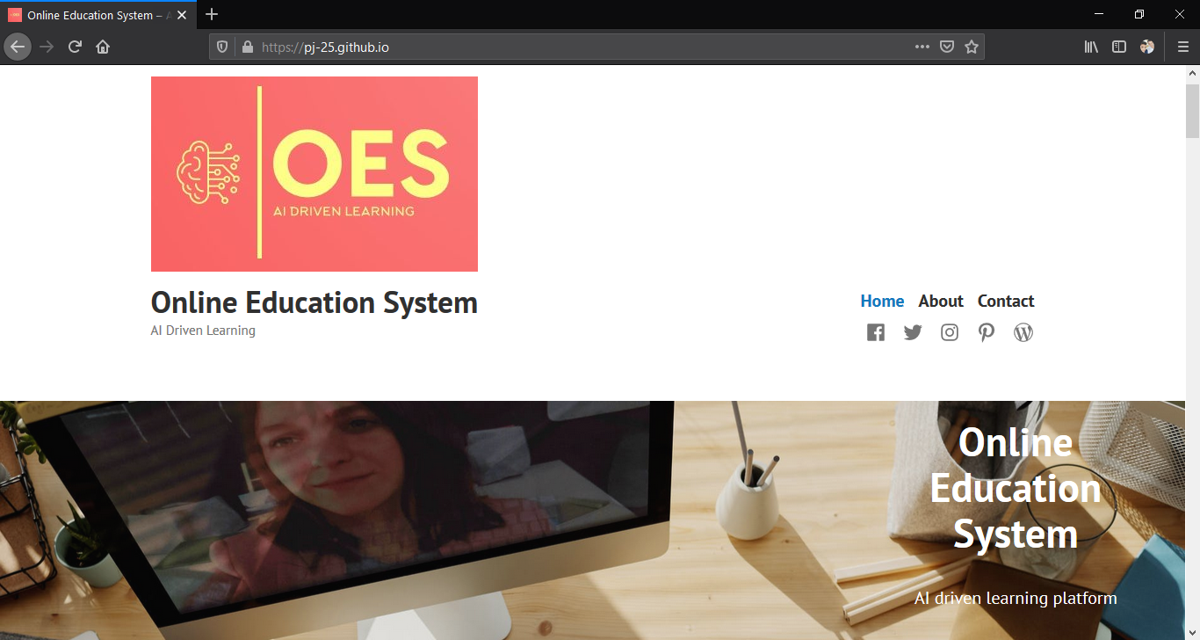

**Desktop view on mobile:**

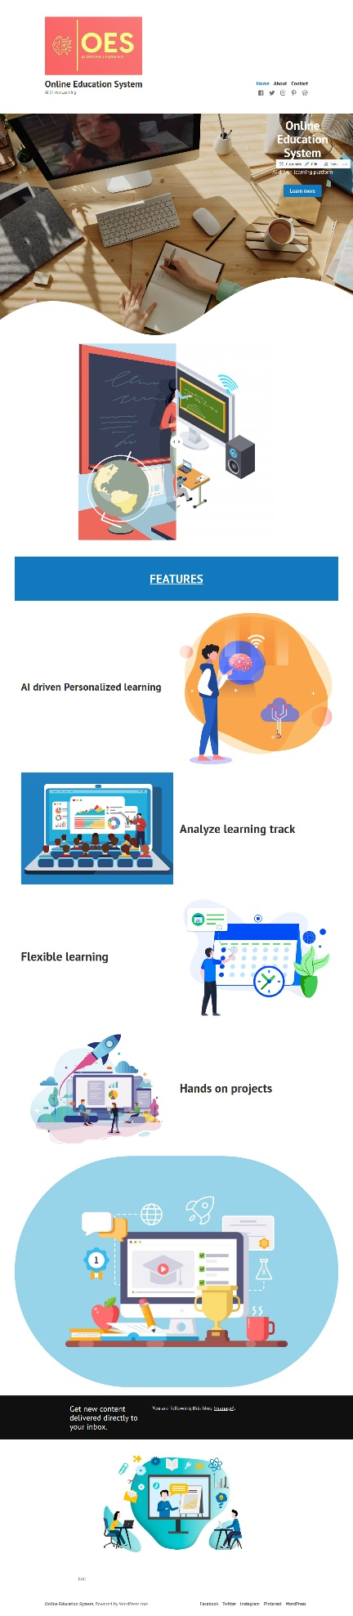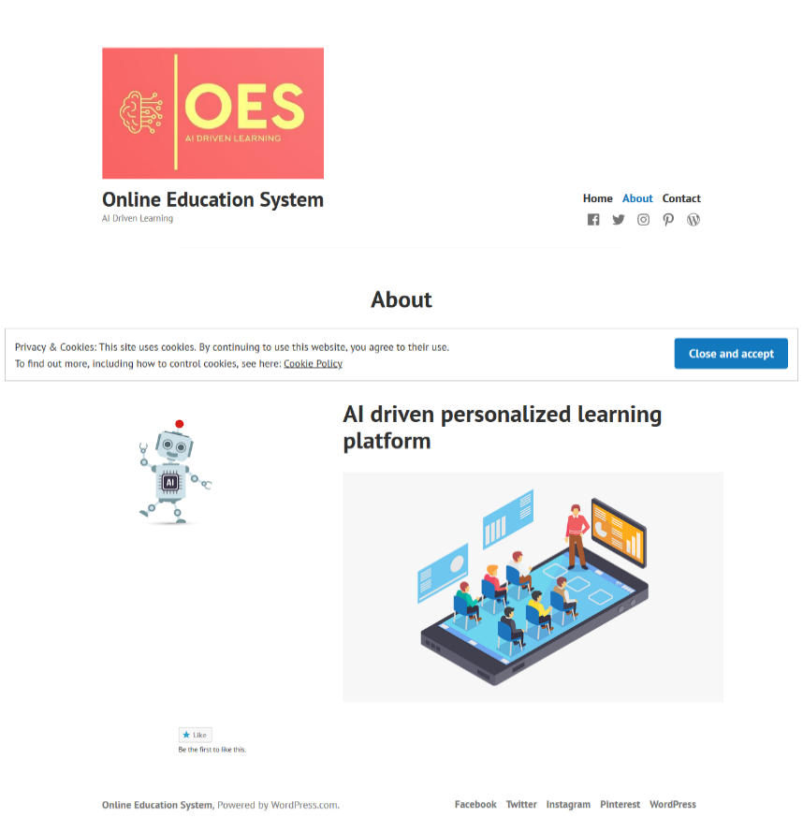

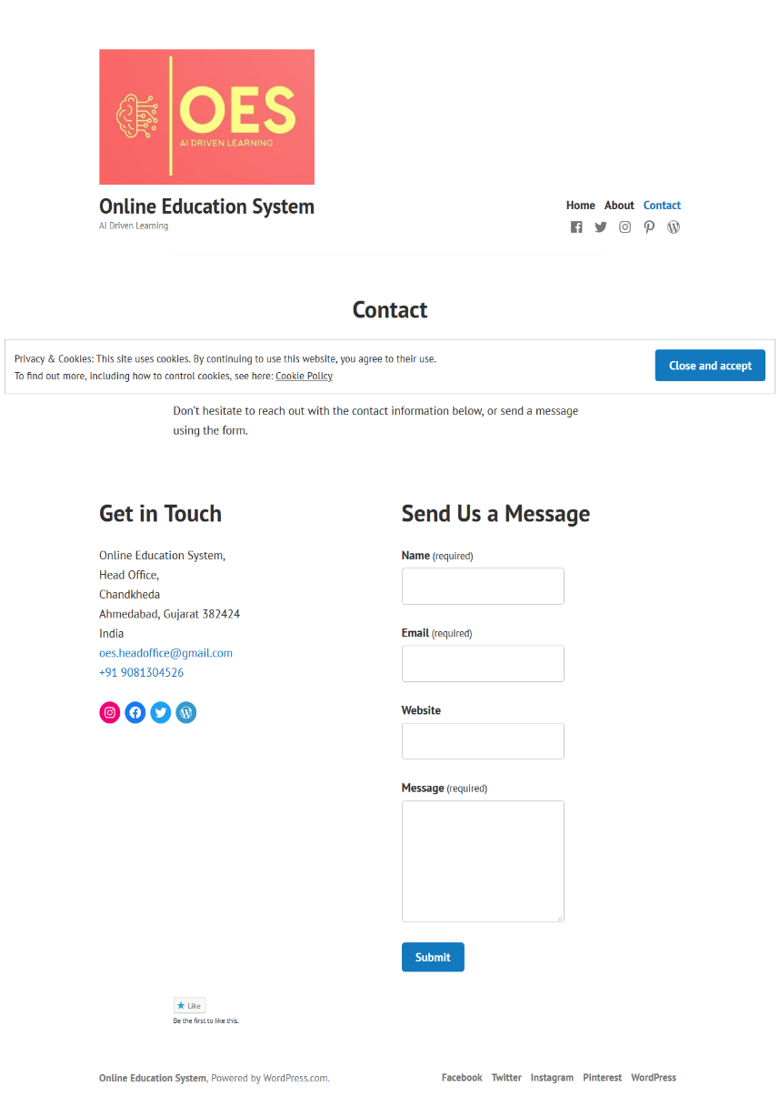

Conclusion

With current situation and immense need for e-learning, there is greater need to provide learner with the flexibility in learning. This platform would open up infinite options for any student and enthusiast to choose from. AI driven paradigm would equip them with better learning experience and flexibility in learning. Though we would have a mammoth task in building an AI that is more human centric and recommending the courses that he/she would need in future. With this platform, e-learning would be on next level, bringing a degree of freedom in learning according to ones learning style and pace.

There is a mere flipside in providing them with flexibility, because human brains are trained to do work with deadlines. Minimizing this would bring greater impact on learners providing an endless resource to learn and developing & upgrading skills in hand. Personalized learning would have greater impact on learners and society in general.